Information Literacy Exit Survey

# Q1

Think back to the beginning of the semester **before** covering information literacy concepts in this course. How would you describe your level of confidence in the following on a scale of 1 (not confident at all) to 5 (extremely confident):

| * Finding information | [find1] |
| --- | --- |
| * Evaluating information | [evaluate1] |
| * Using information | [use1] |
| * Citing information | [cite1] |

How would you describe your level of confidence now, at the end of the semester **after** covering information literacy concepts in this course?

| * Finding information | [find2] |
| --- | --- |
| * Evaluating information | [evaluate2] |
| * Using information | [use2] |
| * Citing information | [cite2] |

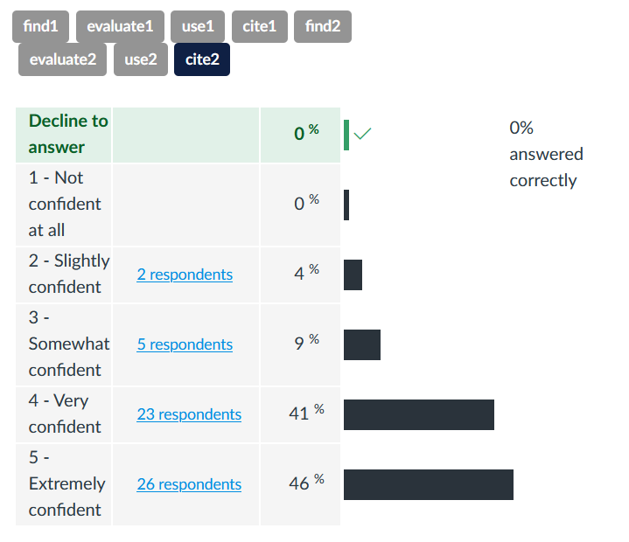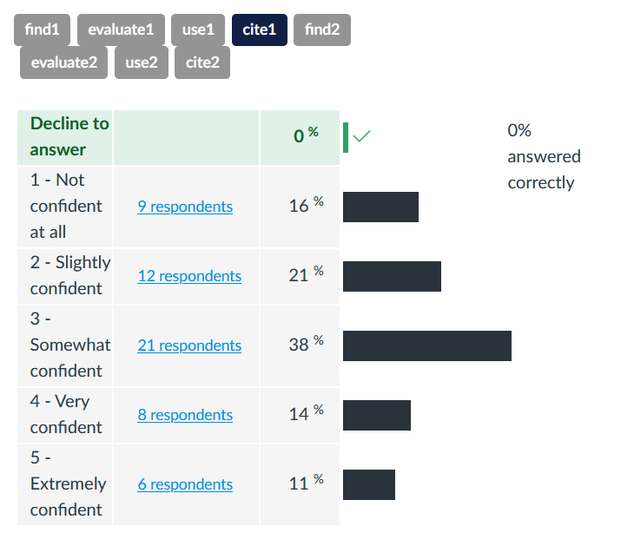

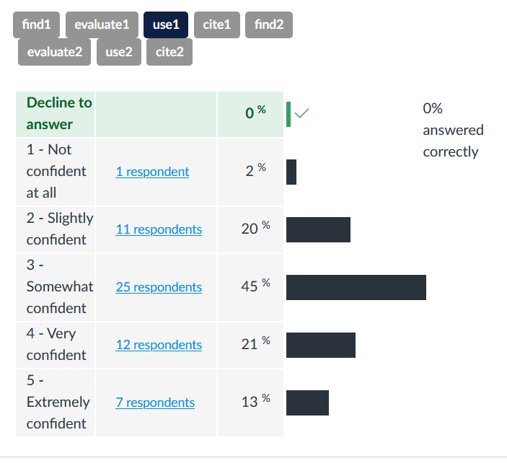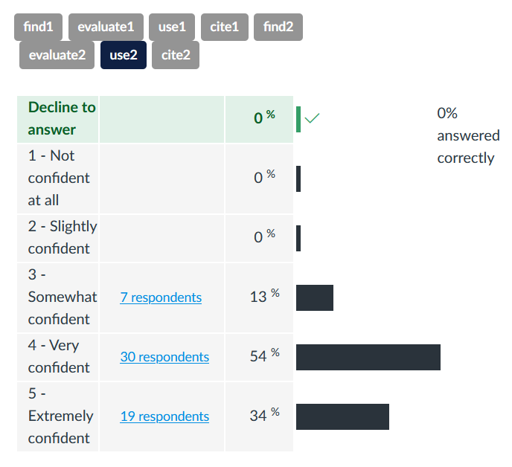

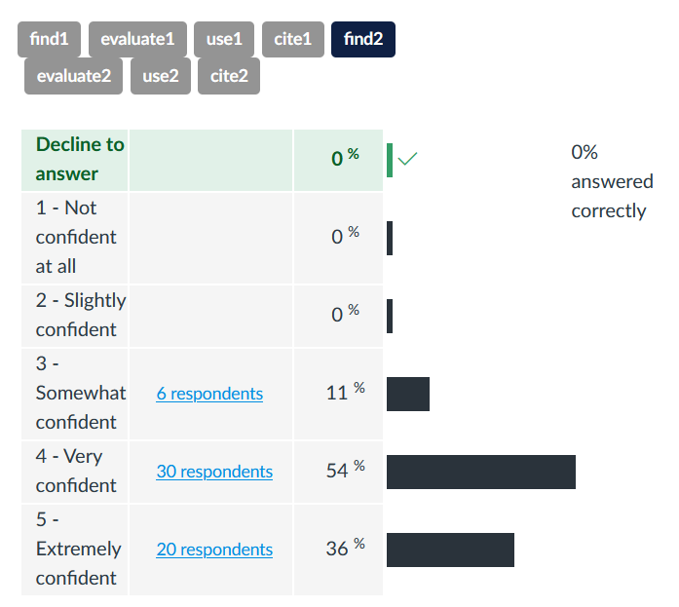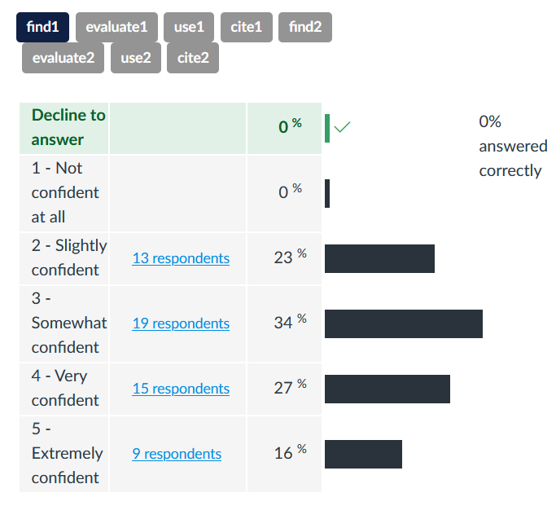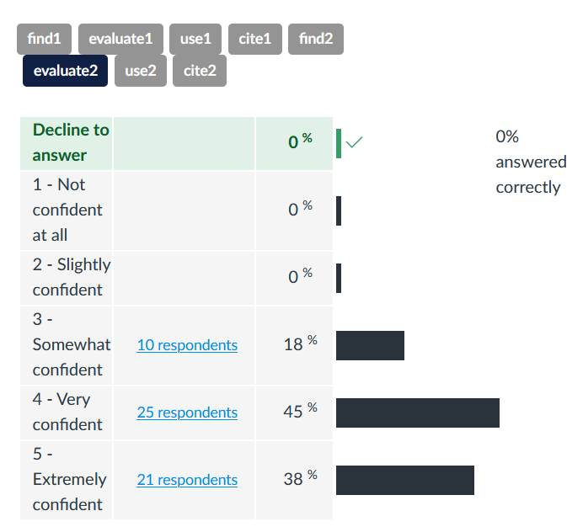

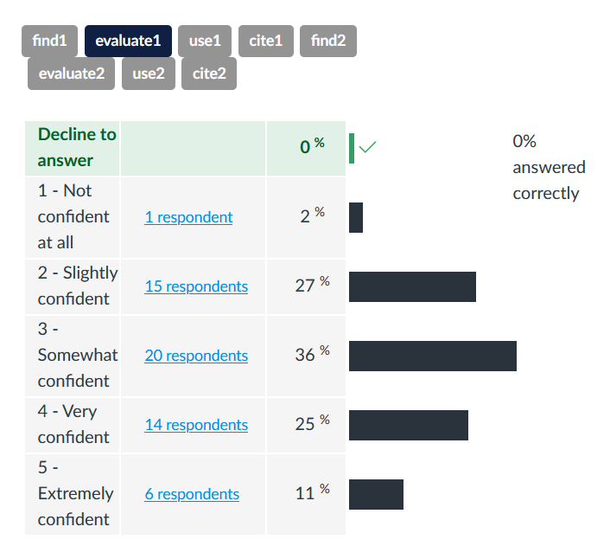

# Q2

Which activities/assignments do you feel helped you learn and/or practice information literacy concepts (i.e. finding, evaluating, using/integrating, and citing information)?

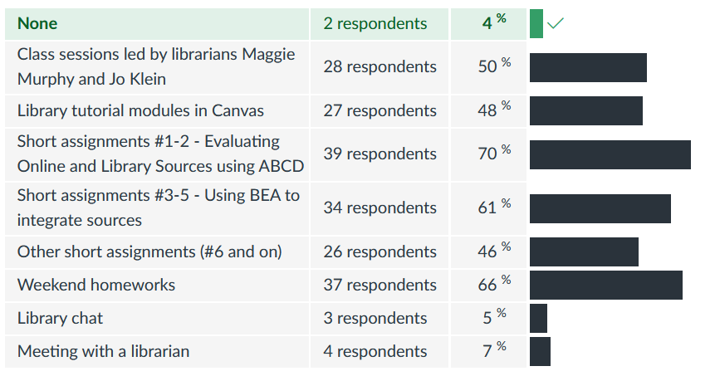

| Class sessions led by librarians Maggie Murphy and Jo Klein | 28 respondents | 50 % |
| --- | --- | --- |
| Library tutorial modules in Canvas | 27 respondents | 48 % |
| Short assignments #1-2 - Evaluating Online and Library Sources using ABCD | 39 respondents | 70 % |
| Short assignments #3-5 - Using BEA to integrate sources | 34 respondents | 61 % |
| Other short assignments (#6 and on) | 26 respondents | 46 % |
| Weekend homeworks | 37 respondents | 66 % |
| Library chatt | 3 respondents | 5 % |
| Meeting with a librarian | 4 respondents | 7 % |

# Q3

What made the assignments from question 3 helpful?

# Q4

What was the most valuable thing you learned from the information literacy activities and assignments in this class?

# Q5

Take some time to reflect on the information literacy skills and concepts you learned in this class.

How do you think they might help you **as a student** in the future?

# Q6

Take some time to reflect on the information literacy skills and concepts you learned in this class.

How do you think they might help you outside of being a student, **in your personal, professional, or civic life**?